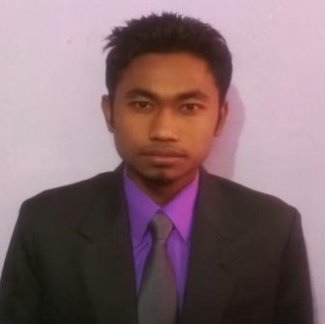**RESUME**

**Name: -**  **AMARJIT HAJONG**

Father’s Name: - LATE BANESWAR PAUL

Address: - VILL- Madhupara, P.O- Garobadha, Dist- South West Garo Hills,

P.S-AMPATI, Meghalaya, Pin code – 794105

Email ID: - amar20191@gmail.com

Phone No.:- +918974369130

+919615819379

**Career Objective**: To Work in a dynamic and highly self motivated organization where my views and ideas will be taken in consideration for the betterment and smooth functioning of the organization to reach the profit goals and a challenging management position where teamwork, versatility, creative thinking, experience and expertise are valued.

**Summer Internship UG:**

* Entreprenuership Training Development, TURA
* Benefits of Vermi Compost, TURA

**Summer Internship PG:**

* Market Study on Handloom Products in Meghalaya with Reference to Shillong City, SHILLONG

**EDUCATION QUALIFICATION:**

|  |  |  |  |  |  |
| --- | --- | --- | --- | --- | --- |
| SL. No. | Examination | Board/ University | Year of passing | Division | Marks (%)/ CGPA |
| 1. | MBA (Marketing/Finance) Waiting for Result | ICFAI University Meghalaya | 2014 |  | Present CGPA till semester 2nd is 7.11 |
| 2. | BBA | ICFAI University Meghalaya | 2012 | 2nd | 5.24 CGPA |
| 3. | H.S.S.L.C  (Commerce) | M.B.O.S.E | 2008 | 3rd | 41.00 |
| 4. | S.S.L.C | M.B.O.S.E | 2006 | 2nd | 47.33 |

**SKILLS:**

* Good Communication skills
* Good Time Management skills
* Good Interpersonal skills
* Basic Knowledge of Computers

**LANGUAGE PROFICIENCY:**

|  |  |  |  |
| --- | --- | --- | --- |
| Sl. No. | Read | Write | Speak |
| 1. | English | English | English |
| 2. | Garo | Garo | Garo |
| 3. | Hindi |  | Hindi |
| 4. |  |  | Bengali |
| 5. |  |  | Assamese |

**Hobbies**: Cricket and Table Tennis

**PERSONAL PROFILE:**

* Date of birth : 20th January 1991
* Gender : Male
* Marital Status : Unmarried
* Nationally : Indian
* Religion : Hindu
* Community : Scheduled Tribe
* Hobbies : Playing Cricket, Table Tennis.

**DECLARATION:**

I hereby declare that all the above mentioned facts are true to my knowledge and belief.



Date:10 /07/2014

Place: Shillong AMARJIT HAJONG